Module Code | IY455
Group | A
Module Title | Information Systems Analysis and Design
Assessment Type | Coursework Stage 1
Module Tutor Name | Majumdar Sharmila
Student ID Number | P488018
Date of Submission | 11/02/2026

ü I confirm that this assignment is my own work. Where I have referred to academic sources, I have provided in-text citations and included the sources in the final reference list.
ü Where I have used AI, I have cited and referenced appropriately.

Loan Table
Loan_DVD Table
Loan_Borrower Table

Borrower Table
DVD Table
Loan Info


Borrower Info

DVD Info
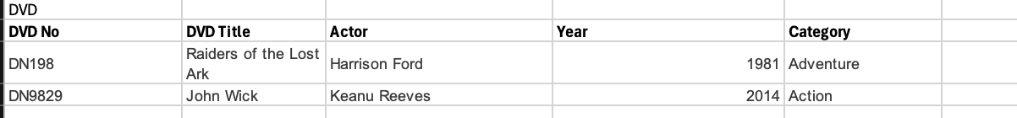

ER Diagram
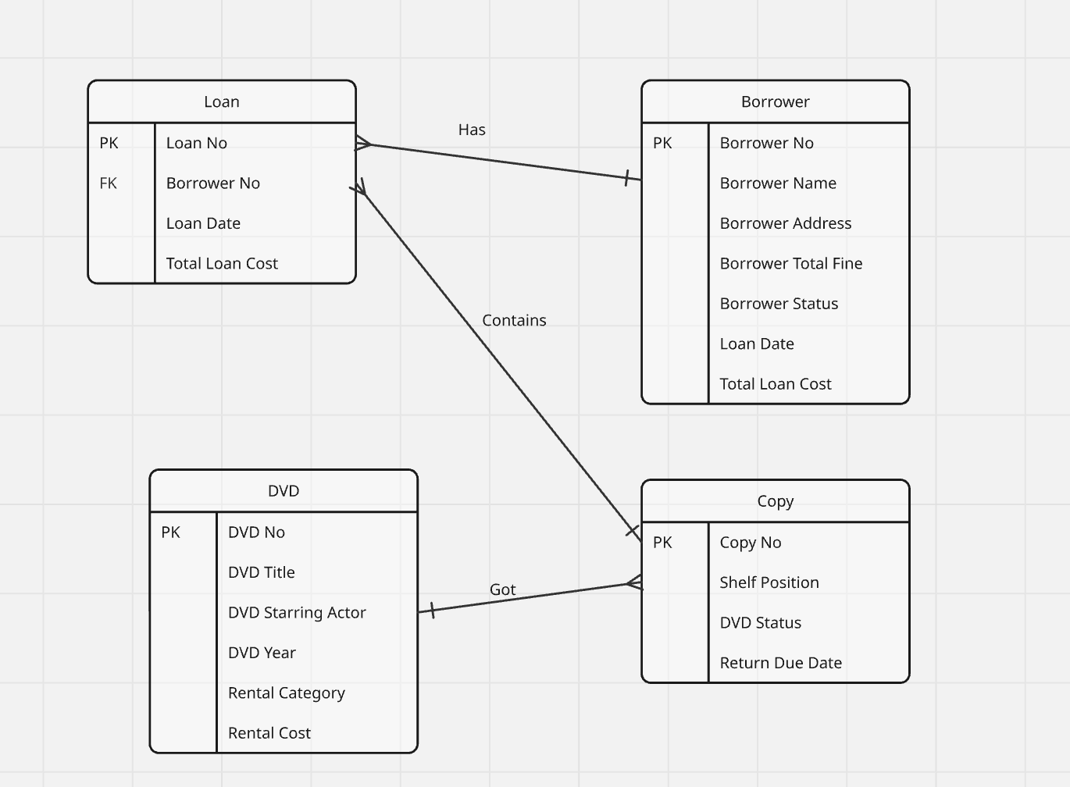

Normalisation
This is the process of putting entries in a databse in an organised manner to show each one of them clearly.
Advantages
Reduce problems with data consistency by reducing redundancy
Petersen, J.V (2002). Absolute Beginner’s Guide to Databases. [O’REILLY]. Retrieved from: https://learning.oreilly.com/library/view/absolute-beginners-guide/078972569X/078972569X_ch04lev1sec1.html#ch04lev1sec1. [Accessed February 2026].
Peterson (2002) argues that normalisation helps with information firmness as it decreases repetition.
Reduce complex user views to a set of manageable and stable data structures

It helps in combining data item types in relational database design to form record types that naturally and completely describe entities and the relationships between entities
Fong, J.S.P. and Yan, K.W.T. (2021). Information Systems Reengineering, Integration and Normalization. Switzerland: Heterogenous Database Connectivity., Retrieved from: https://link.springer.com/book/10.1007/978-3-030-79584-9 [Accessed 11 February 2026]

Fong and Yan (2021) claim that normalisation decreases complicated persons perspective into specified workable along with balanced information design and brings information component brands in relational database design creating record types which easily and entirely characterize entities as well as relationships in entities.
Disadvantages
Increased Complexity: Normalization can lead to more complex database structures. As tables are split into smaller, more specific entities, the relationships between these entities become more intricate. This complexity can make the database harder to understand and manage.
Performance Issues: The process of normalizing databases often involves breaking down tables into smaller ones, which can lead to an increase in the number of joins required to retrieve data. This can slow down query performance, especially on large datasets.
Tencent Cloud. (2025). What are the disadvantages of database normalisation. Retrieved from: https://www.tencentcloud.com/techpedia/108272 [Accessed 11 February 2026].
According to Tencent Cloud (2018), normalisation adds onto complication and causes problems in the working of the database.

